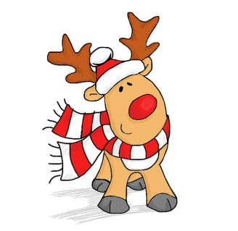Starbuck Area
Chamber of Commerce
Christmas Extravaganza
Arts & Craft Fair!

Seeking crafters and vendors with unique items
to participate in our event at the Starbuck Community Center

The event will be Saturday, October 29th, 2022
9-2 p.m. Set – up starting at 7 a.m.
Early Set – Up Friday October 28th 5pm-7pm

Starbuck Community Center is located at
307 East 5th St., Starbuck, MN 56381

Price for 10x10 ft Booth Space- $40.00

Application/reservation on page 2

Registration for Christmas Extravaganza Arts & Craft Fair

Mail to Laura Aaberg
PO BOX 492
Starbuck, MN 56381
320-424-2358

Please enclose registration fee and tax permit slip

Name________________________________________________ Telephone#__________________________
Business Name_________________________________________
Address______________________________________________
____________________________________________________
Items to be Sold_______________________________________
E-Mail Address________________________________________

I understand that the Starbuck Area Chamber of Commerce,
Board Members, or any other entity involved with this event will not be responsible for any loss or accidents.

Signature______________________________
Tax Permit ID#___________

