Growing on the Prairie
Chamber Member Highlights
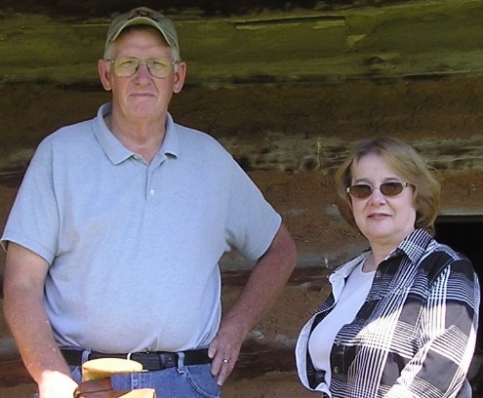
Spring 2024, David and Mona Gregersen
David and Mona Gregersen met in Starbuck after finishing their schooling, but their younger years were spent elsewhere. David’s dad was born in Denmark and when his family moved to the United States, they settled first in Iowa. They moved to the Starbuck area when he was in third grade. After college, David spent 2 years in the Peace Corps teaching in The Gambia. Coming back to Starbuck, his working life included many years of doing artificial insemination and then 15 years of working at DyCast.

Mona’s family lived south of Starbuck, she was born in Benson, but they moved to the Sunburg/Kerkhoven area where she spent her growing up years. She moved back to Starbuck (who knew that would happen?) after college as she was teaching art in the Chokio/Albera school district. She taught there for 18 years, then spent the next 17 years teaching art in the Alex school district.

David and Mona have three children; twin sons now living in Fargo and Los Angeles, and a daughter whose family is also in Fargo, including their 2 grandchildren.

They made their home across the street from the Minnewaska Nursing home, on the north side of Hwy 28 and lived there for many years. (I know some former neighbors who still miss them being on the alley!) They “downsized” and moved 2 years ago, not far away, to the new townhomes near the beach. (I loved getting the chance to see what they look like inside!)

We asked them to name three things they like about Starbuck. First out of Mona’s mouth was their church, Fron Lutheran. This congregation of friends are family to them. Secondly, they love the availability and fact that we can get speedy doctor’s appointments. (as a recent Twin Cities transplant, I completely agree with this!) Lastly, they mentioned the ability to be politically active, something that may be more challenging in a huge community.

We asked what business or service they wished was in Starbuck, a clothing store was mentioned first!

Gregersen’s are members of the Starbuck Chamber because they truly want to support any and everything the city does. They are enthusiastic about all activities they’re involved in. They love shopping locally for both goods and services. Simply put, Gregersen’s are full of volunteerism, energy, and fun!

starbuckchamber@gmail.com

